**LOADING THE DATASET**

|  |  |
| --- | --- |
| Team ID | PNT2022TMID13572 |
| Project Name | Global Sales Data Analytics |

We download the dataset form Kaggle. Now we upload the dataset to the IBM Cognos. (IBM Cognos allows users to connect to a wide range of data that is kept in various locations.)

**Dataset:**

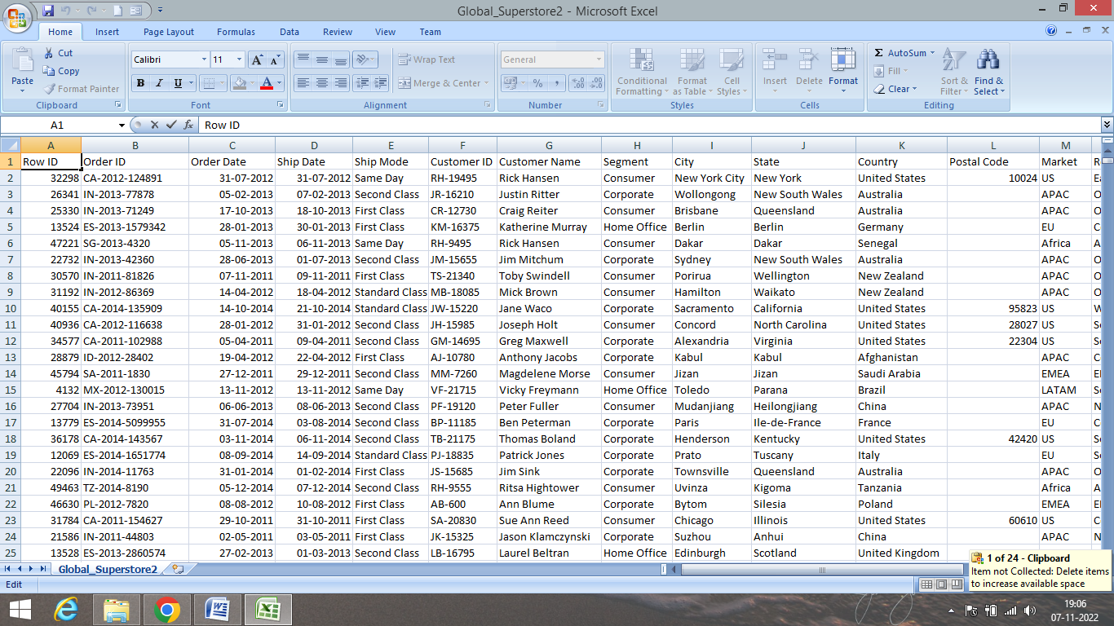

**IBM COGNOS:**

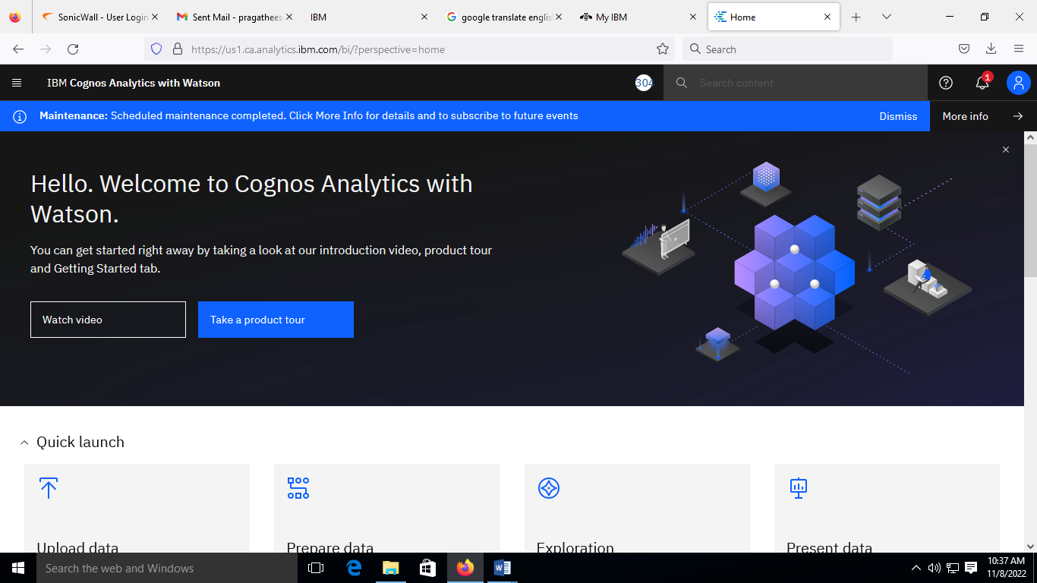

**Uploading the dataset:**

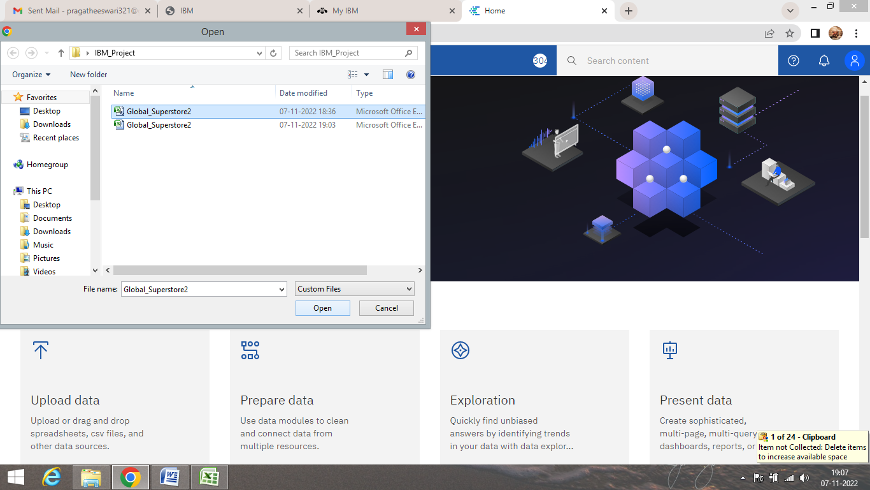

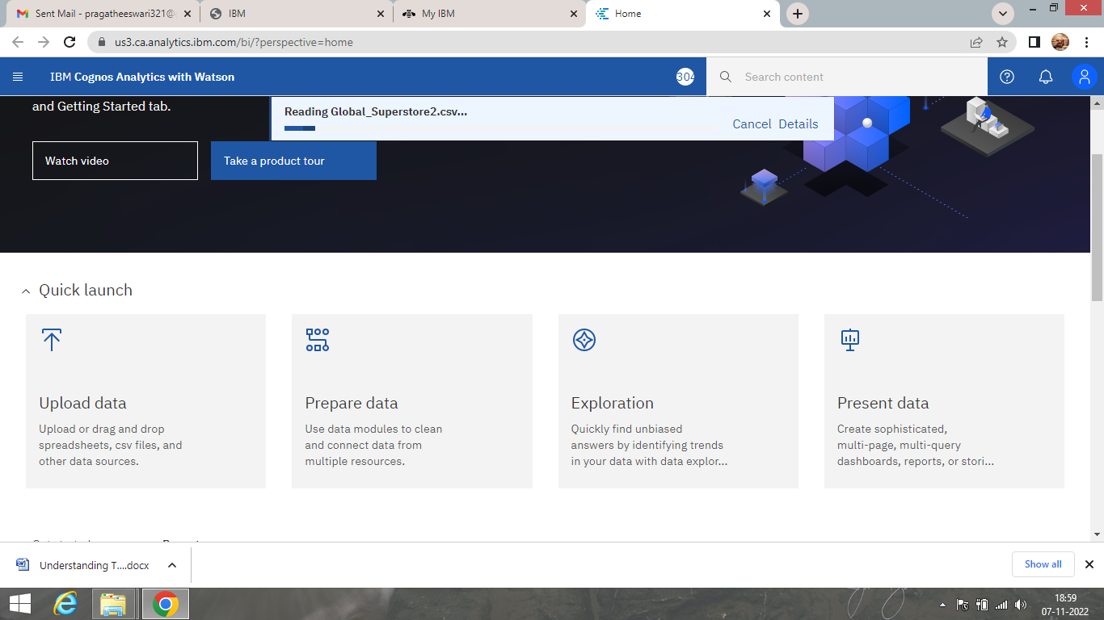

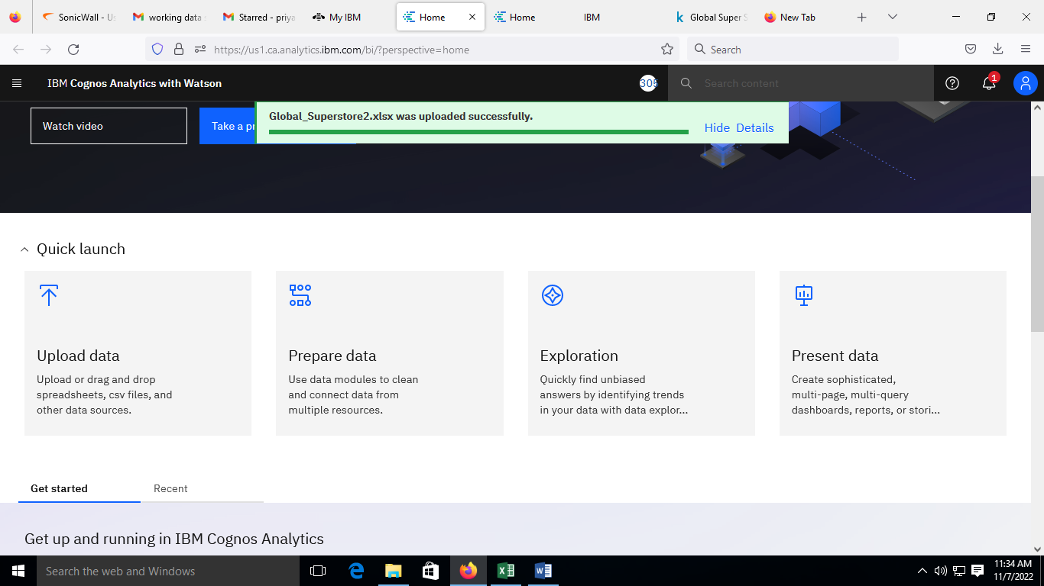

**The dataset was uploaded**

